# Project Documentation & Screenshots

|  |  |  |  |  |
| --- | --- | --- | --- | --- |
| Criteria | | % | Functionality* | Quality of the implementation |
| 1. **Application Design:** Repositories or Providers Class Diagram | | 5% | 100% |  |
| **2) Design and implement** | | **90%** | 100% |  |
|  | U1 – Login | 5 | 100% |  |
| U2 - YalaPay Dashboard | 5 | 100% |  |
| U3 - List/Search/Add/ Update and Delete a customer:  1. List Customers (5 pts)  2. Search Customers (4 pts)  3. Add Customer (6 pts)  4. Update Customer (4 pts)  5. Delete Customer (3 pts) | 22 | `100% |  |
| U4 - List/Search/Add/ Update and Delete an Invoice  1. List Invoices (5 pts)  2. Search Invoices (4 pts)  3. Add Invoice (6 pts)  4. Update Invoice (4 pts)  5. Delete Invoice (3 pts) | 22 | 100% |  |
| U5 - List/Search/Add/ Update and Delete payments for an invoice  1. List Payments (5 pts)  2. Search Payments (4 pts)  3. Add Payment (8 pts)  4. Update Payment (5 pts)  5. Delete Payment (3 pts) | 25 | 100% |  |
| U6 - Manage Cashing Cheques  1. Add Cheques Deposit (10 pts)  2. List Cheque Deposits (5 pts)  3. Update Cheques Deposit (15 pts) | 30 | 100% |  |
| U7 - Invoices Report | 8 | 100% |  |
| U8 - Cheques Report | 8 | 100% |  |
| **3) Testing documentation** using screen shots illustrating the app testing.  - Discussion of the project contribution of each team member [-10pts if not done] | | 5% | 100% |  |
| **Total** | | 100 |  |  |
| Copying and/or plagiarism or not being able to explain or answer questions about the implementation | | -  100 |  |  |

1. Screen for dashboard

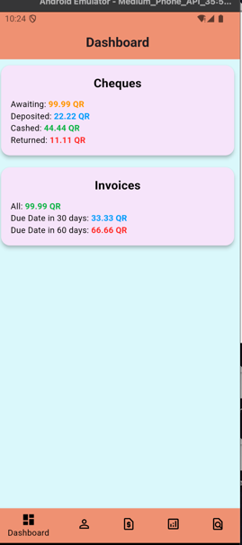

1. Screen related to customers and customer details

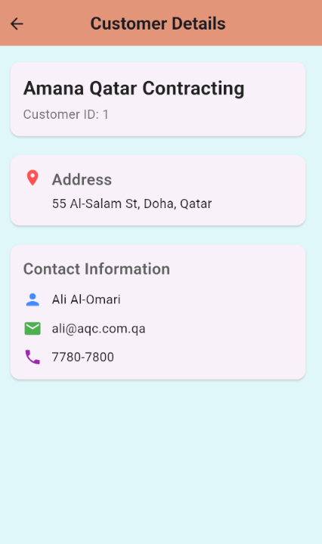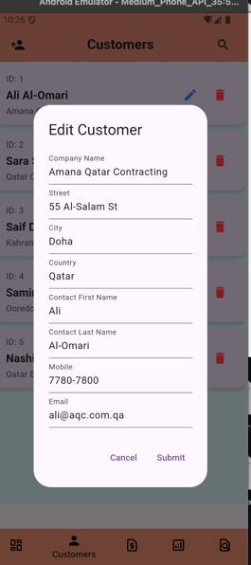

1. Screens related to Invoices and payments

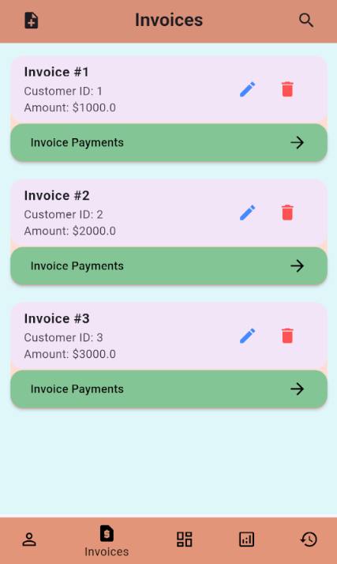 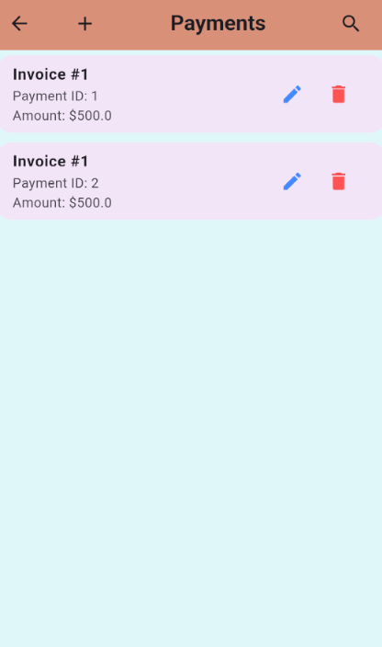

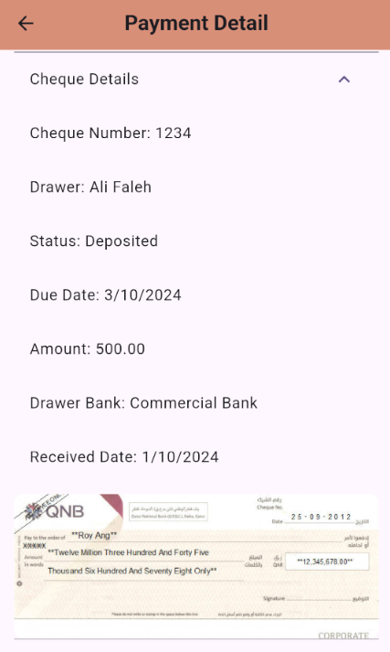

1. Screen related to Cheque Cache

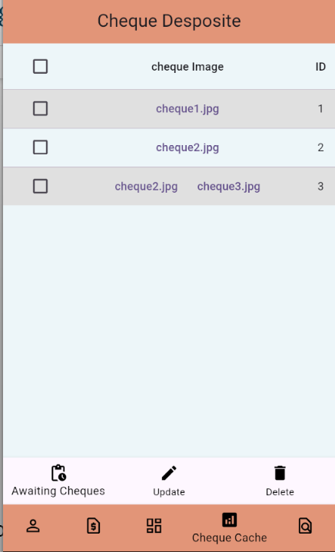

1. Screens related to Invoice and Cheque reports

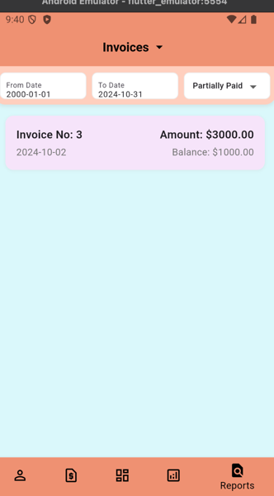 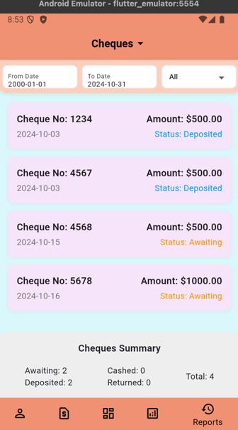

1. Class diagram:

1. Project structure:

.

├── main.dart

├── models

│   ├── bank_account.dart

│   ├── cheque.dart

│   ├── cheque_deposit.dart

│   ├── customer.dart

│   ├── invoice.dart

│   ├── payment.dart

│   ├── return_reason.dart

│   └── user.dart

├── providers

│   ├── bank_account_provider.dart

│   ├── banks_provider.dart

│   ├── cheque_deposit_provider.dart

│   ├── cheque_status_provider.dart

│   ├── cheques_provider.dart

│   ├── customer_provider.dart

│   ├── invoice_provider.dart

│   ├── invoice_status_provider.dart

│   ├── payment_provider.dart

│   ├── return_reason_provider.dart

│   └── user_provider.dart

├── screens

│   ├── awaiting_cheques.dart

│   ├── cheque_cache_screen.dart

│   ├── cheque_detail_screen.dart

│   ├── cheque_report_screen.dart

│   ├── customer_detail_screen.dart

│   ├── customers_screen.dart

│   ├── dashboard.dart

│   ├── invoice_detail_screen.dart

│   ├── invoice_report_screen.dart

│   ├── invoice_screen.dart

│   ├── login.dart

│   ├── payment_detail_screen.dart

│   ├── payment_screen.dart

│   ├── reports_screen.dart

│   └── shell_screen.dart

└── utility

├── customer_tile.dart

├── info_card.dart

├── invoice_tile.dart

├── payment_tile.dart

└── update_deposit_dialog.dart